Student: Brian Johnston

ID: 2019405

Class: COP2362

Assignment: Switch Statement

I worked alone

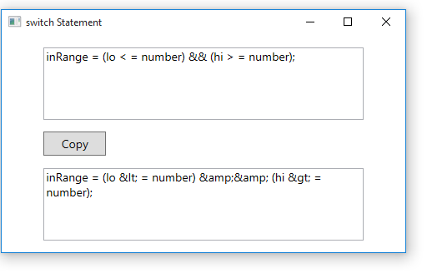

Code:

Mainwindow.xaml.cs

using System;

using System.Collections.Generic;

using System.Linq;

using System.Text;

using System.Windows;

using System.Windows.Controls;

using System.Windows.Data;

using System.Windows.Documents;

using System.Windows.Input;

using System.Windows.Media;

using System.Windows.Media.Imaging;

using System.Windows.Navigation;

using System.Windows.Shapes;

namespace SwitchStatement

{

/// <summary>

/// Interaction logic for MainWindow.xaml

/// </summary>

public partial class MainWindow : Window

{

public MainWindow()

{

InitializeComponent();

}

private void copyClick(object sender, RoutedEventArgs e)

{

target.Text = "";

string from = source.Text;

for (int i = 0; i != from.Length; i++)

{

char current = from[i];

copyOne(current);

}

}

private void copyOne(char current)

{

switch (current)

{

case '<' :

target.Text += "&lt;";

break;

case '>':

target.Text += "&gt;";

break;

case '&' :

target.Text += "&amp;";

break;

case '\"':

target.Text += "&#34;";

break;

case '\'':

target.Text += "#39;";

break;

default:

target.Text += current;

break;

}

}

}

}

Xaml code:

<Window x:Class="SwitchStatement.MainWindow"

xmlns="http://schemas.microsoft.com/winfx/2006/xaml/presentation"

xmlns:x="http://schemas.microsoft.com/winfx/2006/xaml"

Title="switch Statement" Height="300" Width="500">

<Grid>

<Grid Margin="12,0,12,0">

<Grid.RowDefinitions>

<RowDefinition Height="\*"/>

<RowDefinition Height="6\*"/>

<RowDefinition Height="\*"/>

<RowDefinition Height="2\*"/>

<RowDefinition Height="\*"/>

<RowDefinition Height="6\*"/>

<RowDefinition Height="\*"/>

</Grid.RowDefinitions>

<Grid.ColumnDefinitions>

<ColumnDefinition Width="\*"/>

<ColumnDefinition Width="10\*"/>

<ColumnDefinition Width="\*"/>

</Grid.ColumnDefinitions>

<TextBox x:Name="source" Grid.Row="1" Grid.Column="1" HorizontalAlignment="Stretch" VerticalAlignment="Stretch" AcceptsReturn="True" TextWrapping="Wrap" FontSize="14" ScrollViewer.VerticalScrollBarVisibility="Auto"/>

<Button x:Name="copy" Grid.Row="3" Grid.Column="1" HorizontalAlignment="Left" Content="Copy" Click="copyClick" FontSize="14" Width="75"/>

<TextBox x:Name="target" Grid.Row="5" Grid.Column="1" HorizontalAlignment="Stretch" VerticalAlignment="Stretch" AcceptsReturn="True" TextWrapping="Wrap" IsReadOnly="True" FontSize="14" ScrollViewer.VerticalScrollBarVisibility="Auto"/>

</Grid>

</Grid>

</Window>